OPTIMIZED HYBRID RENEWABLE ENERGY SYSTEM FOR WATER DESALINATION PLANT

- INTRODUCTION

Energy is considered as one of the central indexes of social and economic development of any country. Nowadays, almost 80% of the global energy demand is met by means of fossil fuels, resulting in significant environmental impacts. Conventionally, electricity is generated in large thermal power plants and is then transported through high-voltage and medium-voltage distribution grids. However, greenhouse gas (GHG) emissions, the main source of global warming, as well as the air pollution raise a great deal of concerns mainly caused by continuous burning of fossil fuels for electricity generation. On the other hand, rapid depletion of fossil fuel resources on a global scale and progressive increase in energy demand and fuel price are other motives to reduce the reliance on fossil fuels.

Renewable energy sources (RES) are virtually so abundant that they can supply more than the global energy demand. They also can be utilized without any cost for the resource. During the last few decades, RES have shown growing importance in power generation owing to their emission free, environmental friendly and inexhaustible nature.

An optimized hybrid renewable energy system for water desalination plant in Jamnagar and Chennai using HOMER (Hybrid Optimization Model for Electric Renewables) software. To meet the renewable energy system sensitivity analysis and optimization needs, HOMER (Hybrid Optimization Model for Electric Renewables) software has been used to perform the techno economic feasibility of possible configurations. HOMER is an optimization software package, which can handle different technologies (including PV, wind, hydro, fuel cells, and boilers) and evaluate design options for both off-grid and grid-connected power systems for remote, stand-alone, and DG applications. HOMER models each individual system configuration by performing an hourly time-step simulation using inputs such as different technology options, component costs, and resource availability. Then, it investigates technical feasibility of a configuration and estimates the total cost of implementation and operation of the system.

- LOAD DEMAND SPECIFICATION

With a water desalination capacity of 400000 cubic meters per day with reverse osmosis process, the electrical load requirement of the plant is 58333.33 kilowatts per hour. To meet this demand, different configurations are studied to find the optimal configuration for both the cities for on-grid as well as off-grid system.

- RENEWABLE ENERGY RESOURCES IN THE SITES UNDER STUDY

Jamnagar has a hot semi-arid climate. It receives an annual average of 5.76 kWh/m²/day of global solar irradiance and an annual average wind speed of 12.558 m/h. Chennai has a tropical wet and dry climate. It receives an annual average of 5.77 kWh/m²/day of global solar irradiance and an annual average wind speed of 11.066 m/h. Variation of average monthly solar irradiance is depicted in Fig 1. for Jamnagar and Fig 2. for Chennai. Variation of average monthly wind speed with months is depicted in Fig 3. for Jamnagar and Fig 4. for Chennai.

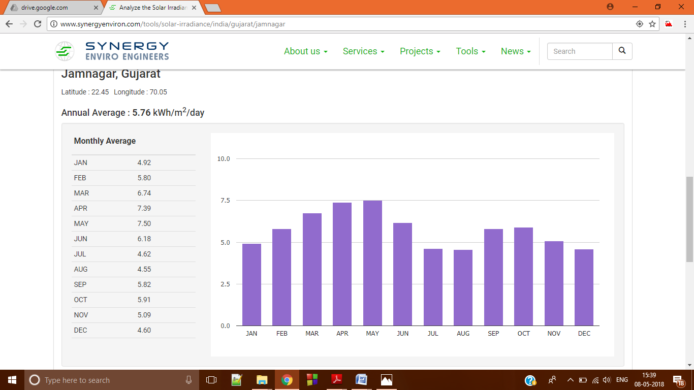
Fig 1. Variation of average monthly solar irradiance for Jamnagar
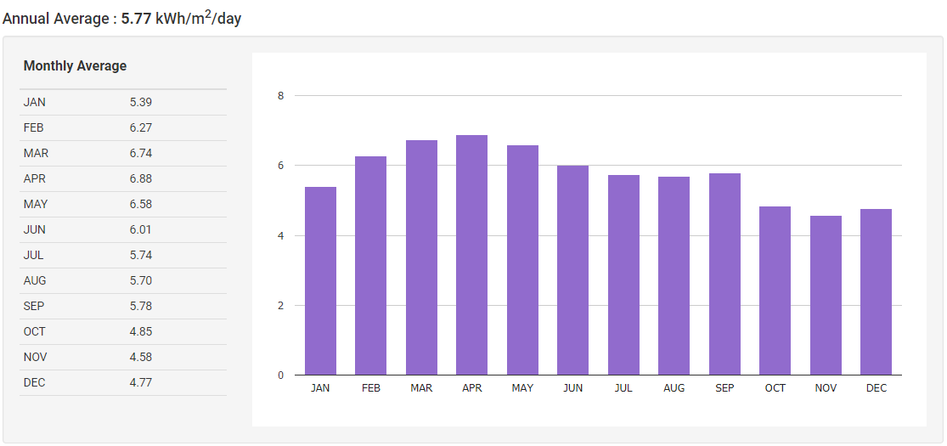

Fig 2. Variation of average monthly solar irradiance for Jamnagar

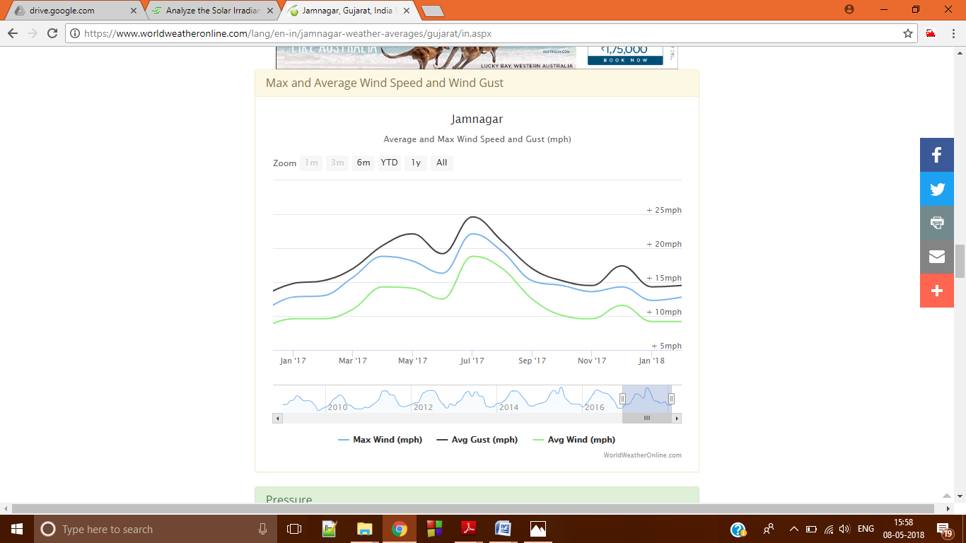
Fig 3. Variation of average monthly wind speed for Jamnagar

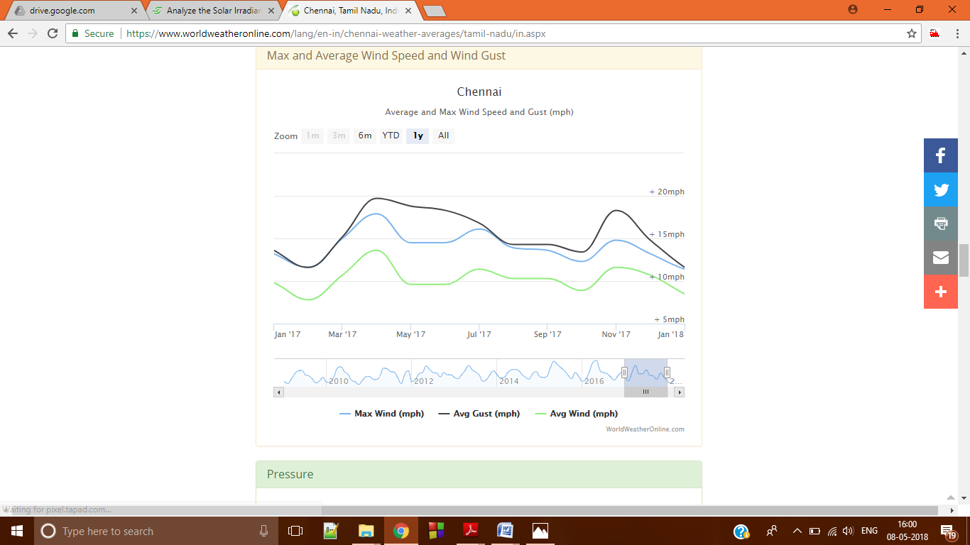
Fig 4. Variation of average monthly wind speed for Chennai

- DESCRIPTION AND SPECIFICATION OF DIFFERENT COMPONENTS AND CONFIGURATIONS

- PV panels
Photovoltaic system is an interconnection PV module producing direct current electricity from solar energy. Solar panels are made of individual solar cells, connected together and usually rated as 12-V solar panels. A 12-V solar panel produces around 14e18 V when connected to a load and also is capable of charging a 12-V battery. Panel type of the PV module used is flat plate. The output power of the PV module can be estimated as follows

- Wind turbine
In a wind turbine, electricity is generated by converting the kinetic energy of wind into electrical energy. Wind turbine farms are becoming important sources of renewable energy and are used to reduce reliance on fossil fuels and consequently pollutant emissions. The wind turbines used in this analysis are Generic 3kW with rated capacity of 3 kW and AC voltage output.

- Converter
The inverter is one of the key components of the system as it converts the DC electricity produced by the PV modules into AC electricity.

- Battery Storage
The inverter is one of the key components of the system as it converts the DC electricity produced by the PV modules into AC electricity. Generic 1kWh lead acid battery is chosen in the present work.

- Advanced Grid
Grid power price for Jamnagar is 0.123 $/kWh with sellback price equal to 0.062 $/kWh.
Grid power price for Chennai is 0.085 $/kWh with sellback price equal to 0.043 $/kWh.
Simulations have been performed for both on grid and off grid.
Specifications of all the components have been listed in Table 1.
Table-1 Specifications of components
S.No. | COMPONENT AND DESCRIPTION | SPECIFICATION
1. | PV module  - Rated Capacity  - Capital cost  - Replacement cost  - O&M cost  - Lifetime  - Derating factor | 1 kW  800 $  800 $  4 $/year  20 years  88%
2. | Wind Turbine  - Rated capacity  - Capital cost  - Replacement cost  - O&M cost  - Lifetime  - Hub height | 3kW  2300 $  1500 $  2 $/year  20 years  50 m
3. | Converter  - Capital cost  - Replacement cost  - O&M cost  - Inverter input lifetime  - Inverter input efficiency  - Rectifier input relative capacity  - Rectifier input efficiency | 127 $  127 $  1 $/year  20 years  90 %  100 %  90 %
4. | Battery storage  - Nominal voltage  - Nominal capacity  - Capital cost  - Replacement cost  - O&M cost  - Lifetime  - Throughput  - Initial state of charge  - Minimum state of charge | 12 V  1kWh  167 $  67 $  1.67 $/year  5 years  800 kWh  100%  30%
5. | Advanced grid  - Grid power price  - Grid sellback price | Jamnagar | Chennai
5. | Advanced grid  - Grid power price  - Grid sellback price | 0.123 $/kWh | 0.085 $/kWh
5. | Advanced grid  - Grid power price  - Grid sellback price | 0.062 $/kWh | 0.043 $/kWh

- ON-GRID HYBRID RENEWABLE ENERGY SYSTEM FOR JAMNAGAR

Table 2. shows comparison of different configurations observed based on Net Present Cost (NPC), Cost Of Energy(COE), Electricity produced by PV, Wind Turbine (WT) and grid and total electric production for designed on-grid energy system for Jamnagar. Fig 5. to Fig 12. show cost summary i.e contribution of PV, wind turbine, converter, grid and battery in capital cost, operating cost, replacement cost and salvage cost in which constitute the NPC for on-grid system designed for Jamnagar . Fig 13. to Fig 20. show the contribution of PV, wind turbine and grid in the monthly average electric production .

Case  No. | Configuration | NPC ($) | COE ($/kWh) | Electricity produced-PV  (kWh/year) | Electricity produced- WT  (kWh/year) | Electricity produced-grid  (kWh/year) | Total Electric  Production  (kWh/year)
1. | PV/CON/GRD | 465M | 0.0281 | 1.094B |  | 279M | 1373M
2. | PV/BS/CON/GRD | 465M | 0.0282 | 1.089B |  | 279M | 1368M
3. | PV/WT/CON/GRD | 466M | 0.0283 | 1.080B | 0.693M | 279M | 1368M
4. | PV/BS/CON/WT/GRD | 472M | 0.0286 | 1.094B | 1.849M | 279M | 1372M
5. | GRD | 812M | 0.123 |  |  | 510M | 510M
6. | WT/GRD | 812M | 0.123 |  | 0.057M | 510M | 511M
7. | CON/GRD | 813M | 0.123 |  |  | 510M | 510M
8. | CON/WT/GRD | 814M | 0.123 |  | 0.592M | 510M | 511M
Table 2. Different configurations observed for designed on-grid system for Jamnagar
C
O
S
T
($)
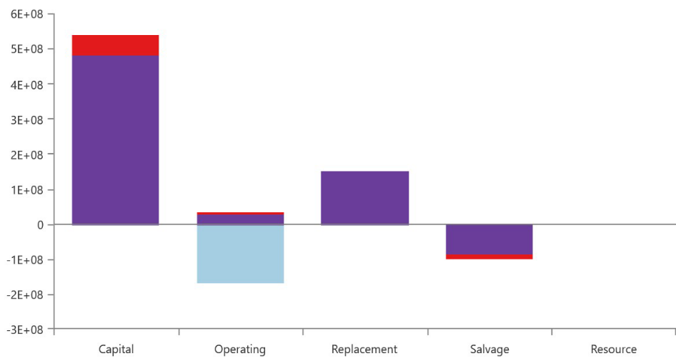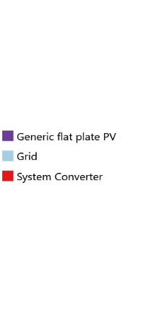

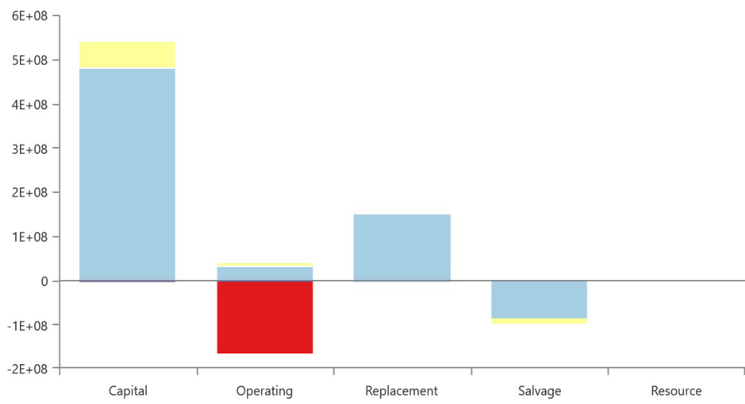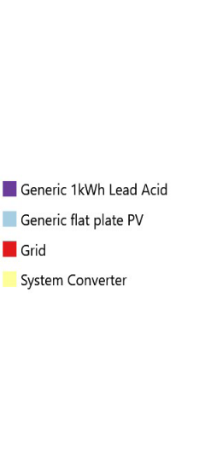

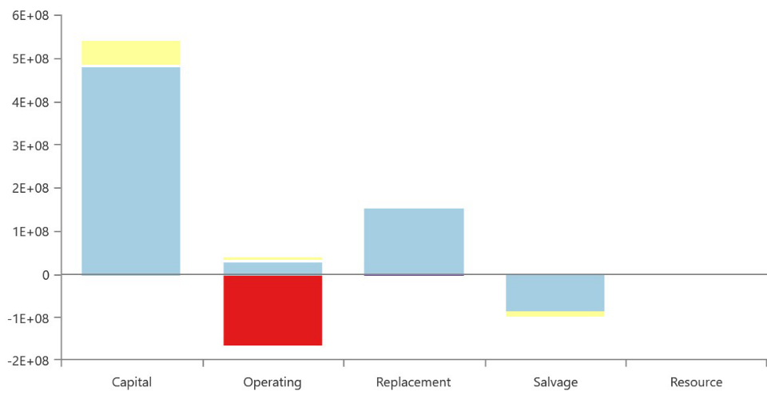
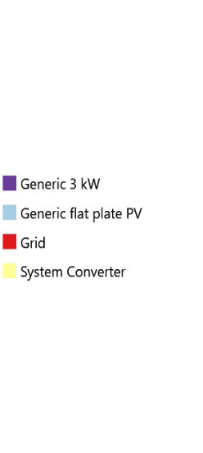
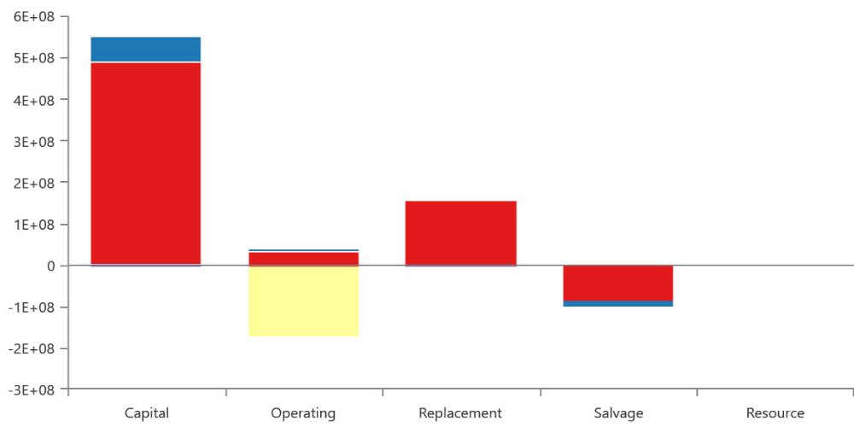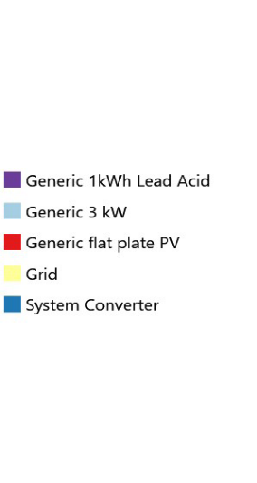
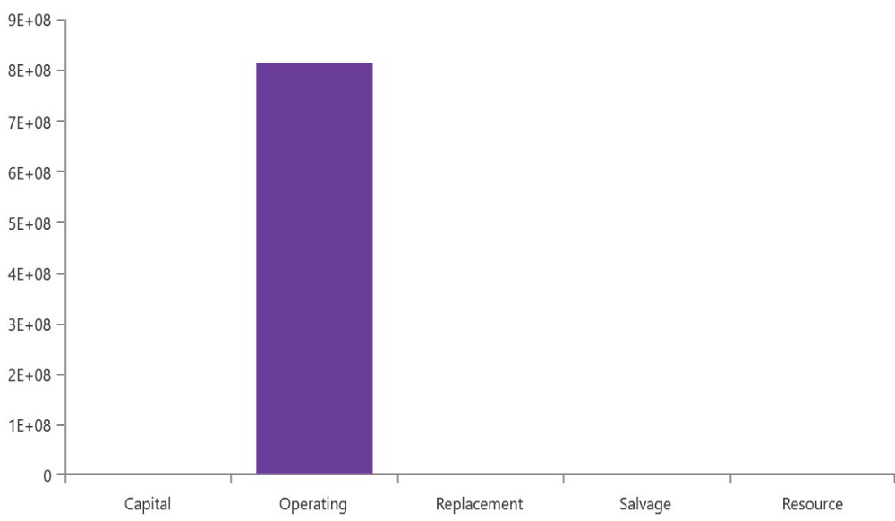
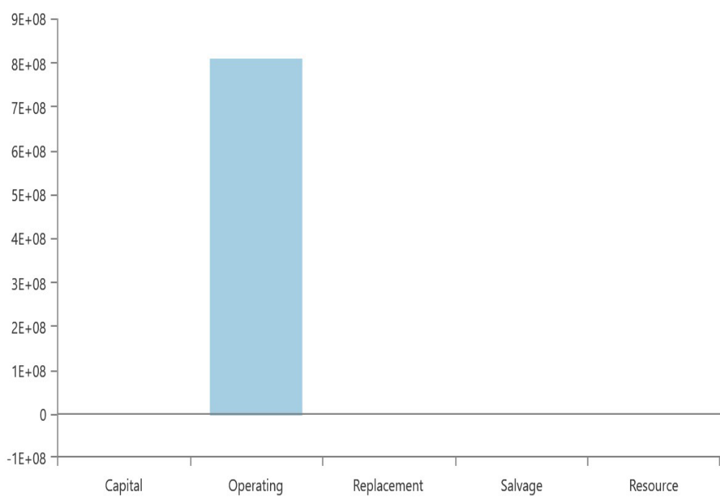



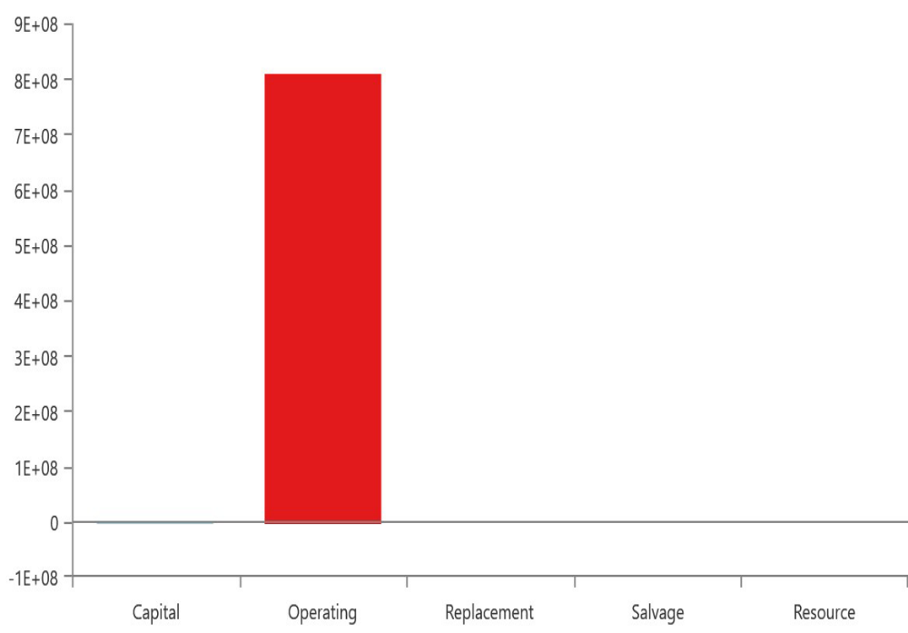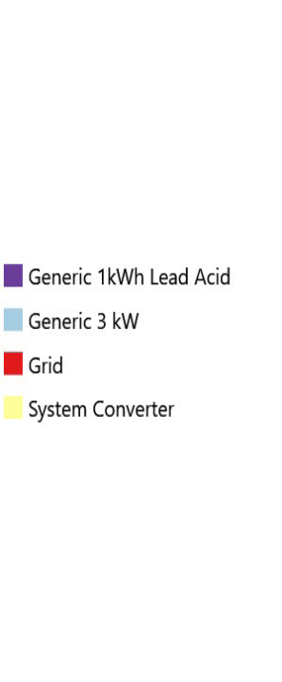

- ON-GRID HYBRID RENEWABLE ENERGY SYSTEM FOR CHENNAI

Table 2. shows comparison of different configurations observed based on Net Present Cost (NPC), Cost Of Energy(COE), Electricity produced by PV, Wind Turbine (WT) and grid and total electric production for designed on-grid energy system for Jamnagar. Fig 5. to Fig 12. show cost summary i.e contribution of PV, wind turbine, converter, grid and battery in capital cost, operating cost, replacement cost and salvage cost in which constitute the NPC for on-grid system designed for Chennai . Fig 13. to Fig 20. show the contribution of PV, wind turbine and grid in the monthly average electric production .

Case  No. | Configuration | NPC ($) | COE ($/kWh) | Electricity produced-PV  (kWh/year) | Electricity produced- WT  (kWh/year) | Electricity produced-grid  (kWh/year) | Total Electric  Production  (kWh/year)
1. | PV/WT/CON/GRD | 503M | 0.0688 | 236M | 26M | 329M | 592M
2. | PV/CON/GRD | 504M | 0.0690 | 247M |  | 349M | 592M
3. | PV/BS/CON/GRD | 504M | 0.0671 | 273M |  | 338M | 612M
4. | WT/GRD | 546M | 0.0813 |  | 93M | 426M | 520M
5. | BS/WT/CON/GRD | 547M | 0.0818 |  | 86M | 430M | 517M
6. | PV/BS/WT/CON/GRD | 553M | 0.0825 | 12M | 91M | 425M | 528M
7. | GRD | 558M | 0.0846 |  |  | 510M | 510M
8. | GRD/BS/CON | 560M | 0.0847 |  |  | 510M | 510M
Table 3. Different configurations observed for designed on-grid system for Chennai

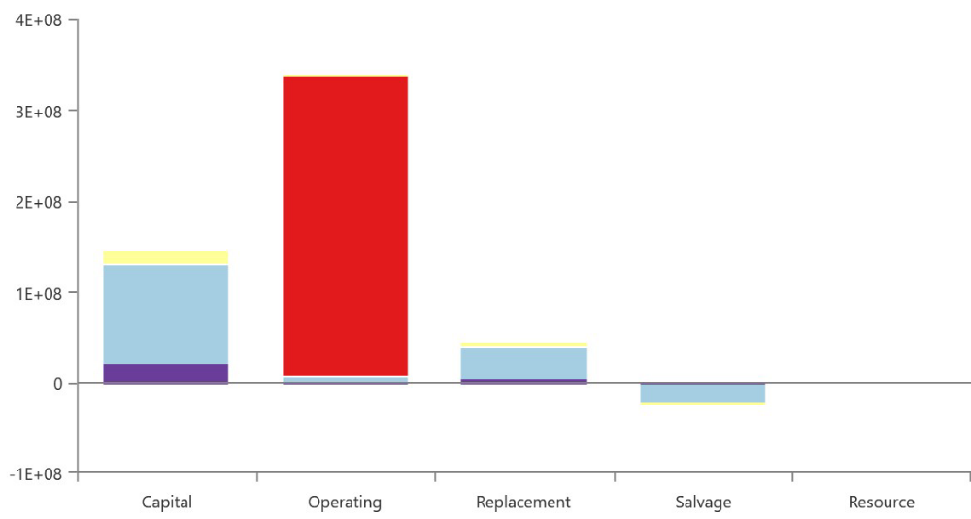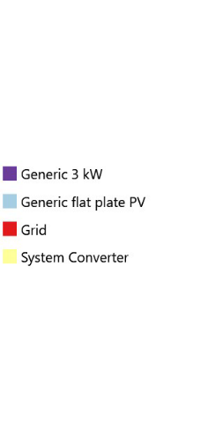

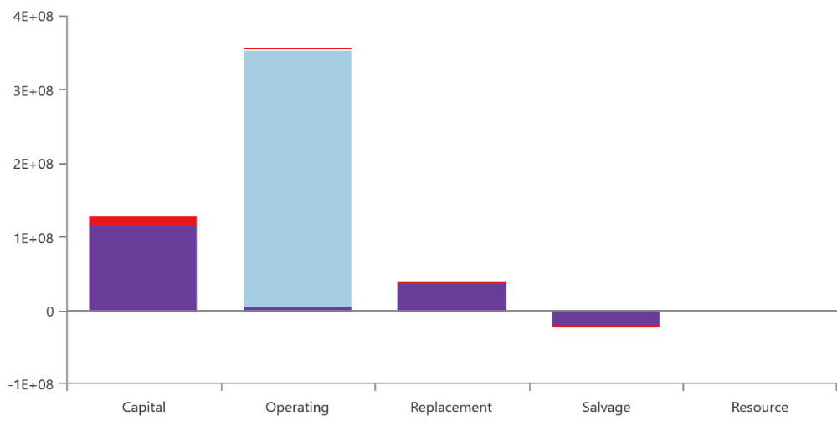
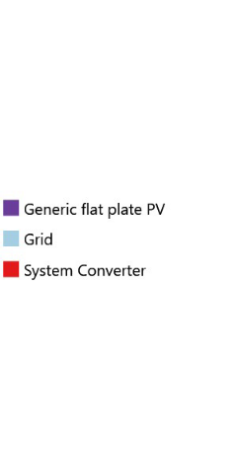

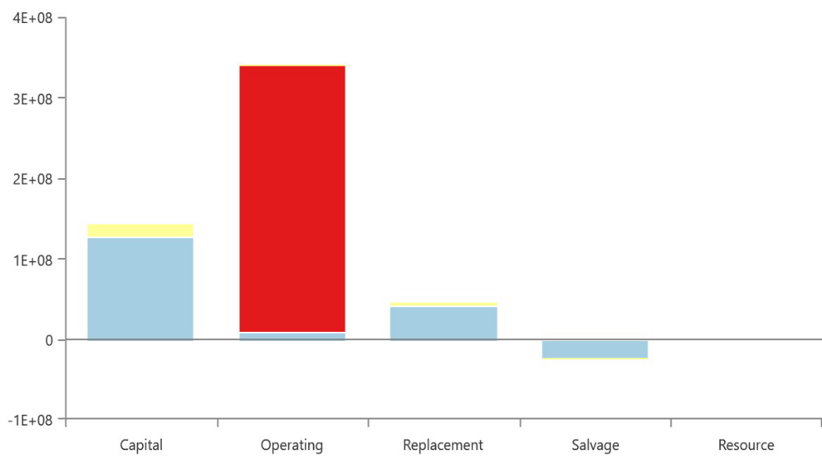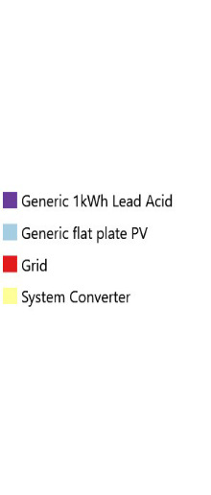

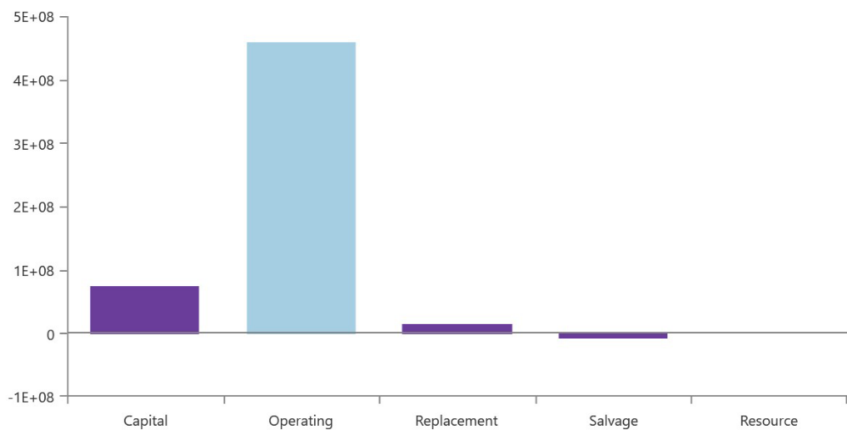

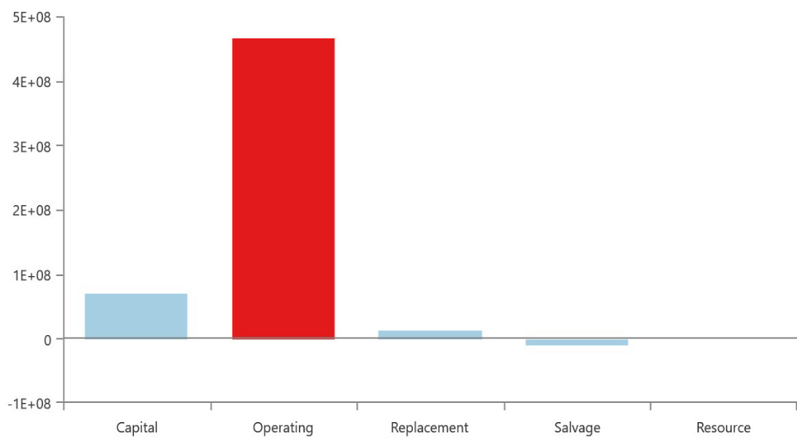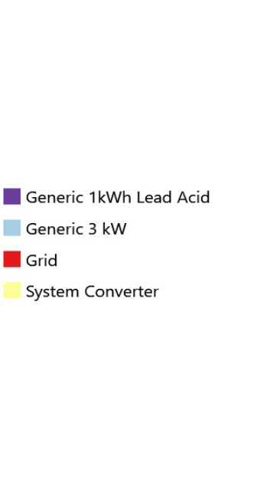

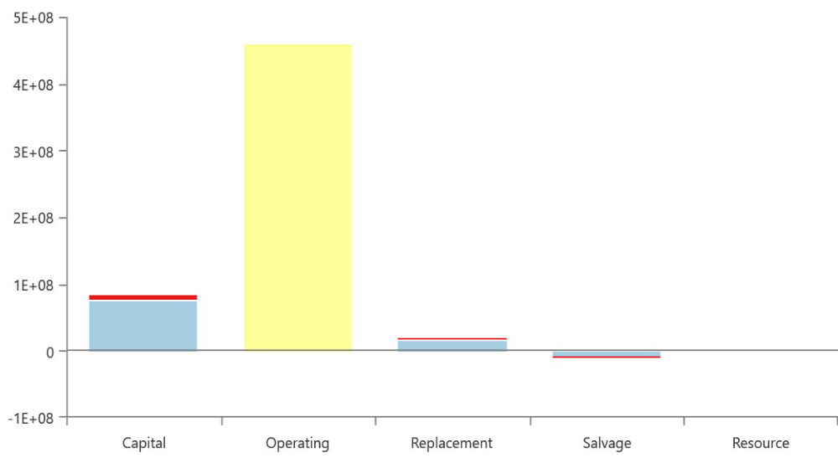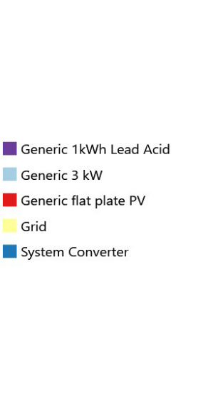
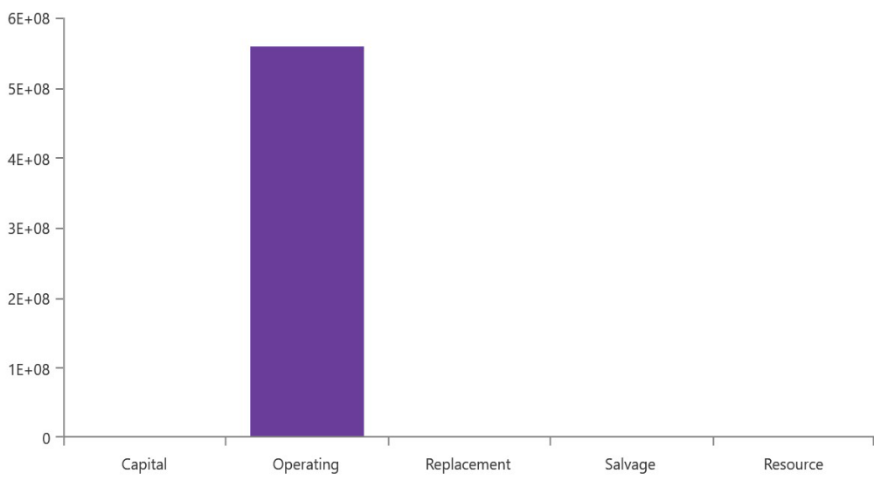
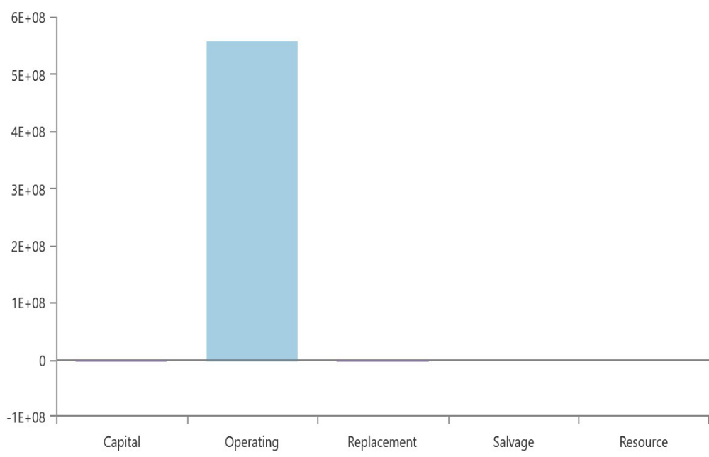

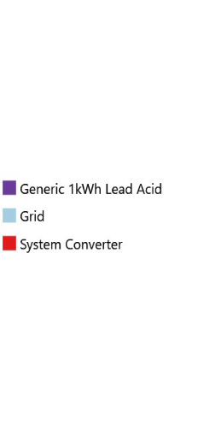

- OFF-GRID HYBRID RENEWABLE ENERGY SYSTEM FOR JAMNAGAR

Table 2. shows comparison of different configurations observed based on Net Present Cost (NPC), Cost Of Energy(COE), Electricity produced by PV, Wind Turbine (WT) and grid and total electric production for designed on-grid energy system for Jamnagar. Fig 5. to Fig 12. show cost summary i.e contribution of PV, wind turbine, converter, grid and battery in capital cost, operating cost, replacement cost and salvage cost in which constitute the NPC for on-grid system designed for Jamnagar . Fig 13. to Fig 20. show the contribution of PV, wind turbine and grid in the monthly average electric production .

Case no. | Configuration | NPC ($) | COE ($/kWh) | Electricity produced-PV  (kWh/year) | Electricity produced- WT  (kWh/year) | Total Electric  Production  (kWh/year)
1. | PV/BS/CON | 2.40B | 0.364 | 2.54B |  | 2.54B
2. | PV/BS/WT/CON | 2.41B | 0.366 | 2.11B | 124M | 2.24B
Table 4. Different configurations observed for designed off- grid system for Jamnagar
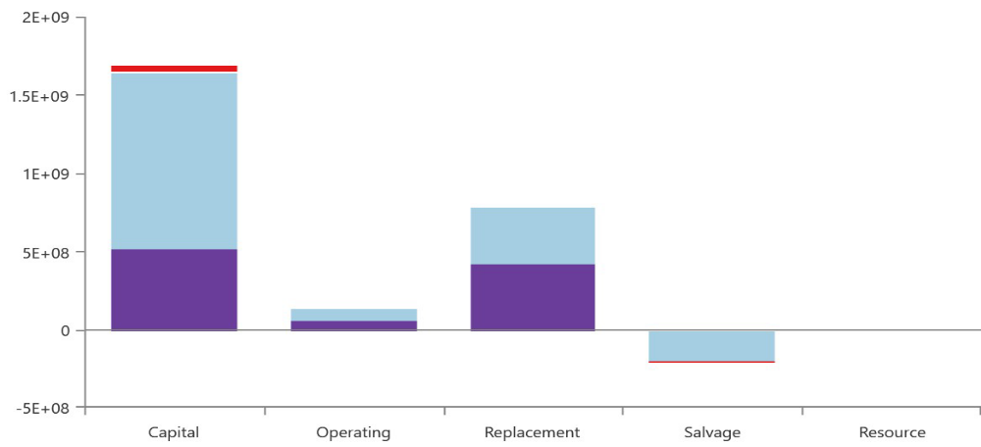
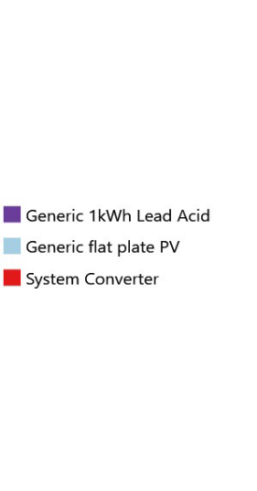

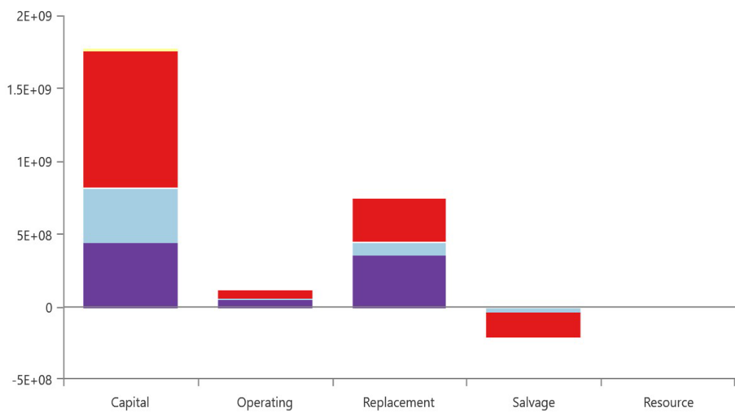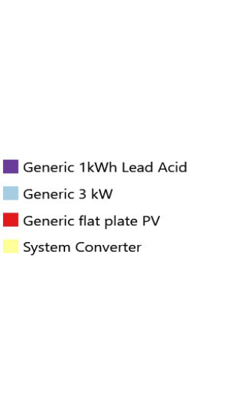

- OFF-GRID HYBRID RENEWABLE ENERGY SYSTEM FOR CHENNAI

Table 2. shows comparison of different configurations observed based on Net Present Cost (NPC), Cost Of Energy(COE), Electricity produced by PV, Wind Turbine (WT) and grid and total electric production for designed on-grid energy system for Jamnagar. Fig 5. to Fig 12. show cost summary i.e contribution of PV, wind turbine, converter, grid and battery in capital cost, operating cost, replacement cost and salvage cost in which constitute the NPC for on-grid system designed for Chennai. Fig 13. to Fig 20. show the contribution of PV, wind turbine and grid in the monthly average electric production .

CHENNAI WITHOUT GRID
S.No. | Configuration | NPC ($) | COE ($/kWh) | Electricity produced-PV  (kWh/year) | Electricity produced- WT  (kWh/year) | Total Electric  Production  (kWh/year)
1. | PV/BS/WT/CON | 2.03B | 0.308 | 1.92B | 168M | 2.09B
2. | PV/BS/CON | 2.20B | 0.334 | 2.14B |  | 2.14B
Table 2. Different configurations observed for designed on- grid system for Jamnagar
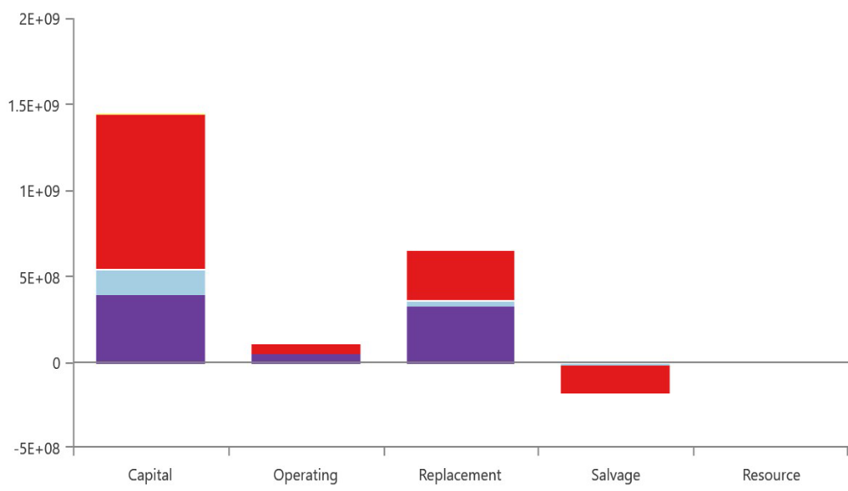
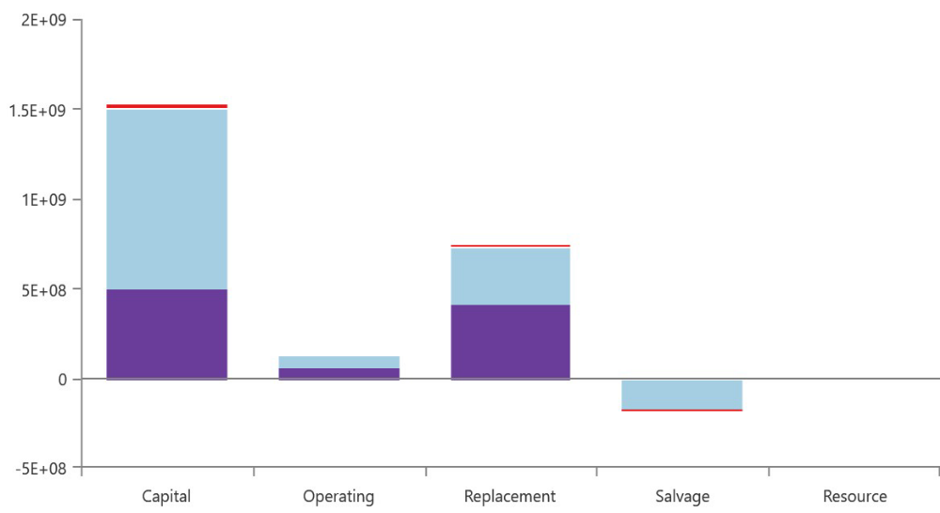

City | With/Without grid | Best configuration | Total Net Present Cost($)
Jamnagar | Without grid | PV/BS/CON | 2.40B
Chennai | Without grid | PV/WT/CON | 2.03B
Jamnagar | With grid | PV/GRD/CON | 465M
Chennai | With grid | PV/WT/GRD/CON | 503M
Best configurations of on-grid and off-grid system for both the cities
It is observed that
Graphs---cost summary
Electric pro

